**Data Profiling**

The profiling below demonstrates a very brief overview of any trends I have found within the data. I believe it is outside the scope of this project to perform a rigorous analysis on this data set, and therefore when I have used the words significant, I mean “immediately obvious” and not that these results are statistically significant.

I have specifically looked at the average length of episodes, and the average number of episodes across different ages, genders, and ethnicities. I have then included some more general profiling graphs that I thought might be of interest to the reader.

**Ethnos**

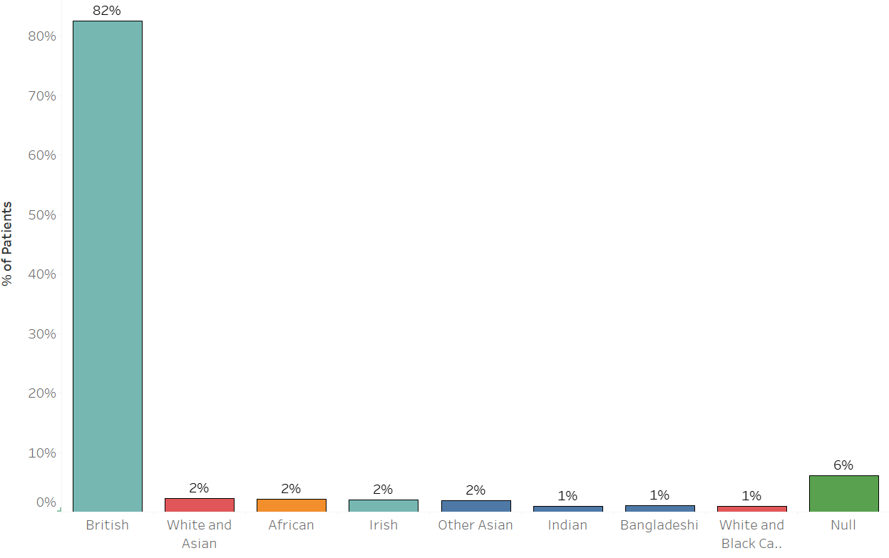

The above graph illustrates that the majority of patients were of British ethnicity.

**Average Stay Duration**

The chart above indicates that patients who are older or younger tend to have longer stays in hospital. However, I have also included the number of data points for each year of birth to indicate that there will almost certainly be insufficient data points to draw any conclusions.

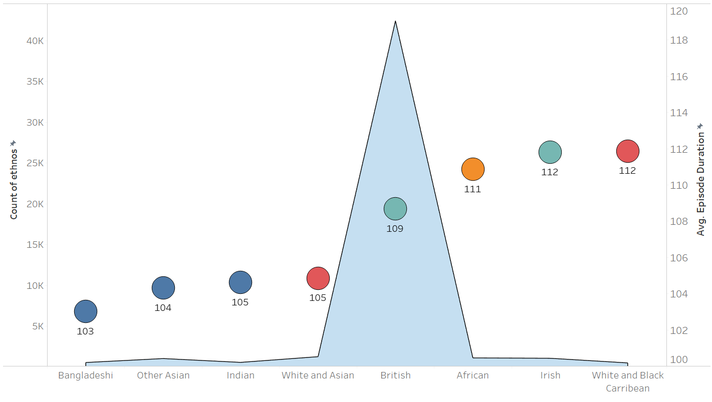

The graph above plots average stay duration (the dots) and total number of data points for each

Doing a quick analysis of Avg. Episode duration for each ethos, we can see that patients in the Asian/Asian British Ethnic group usually have shorter stays than those of other ethnicities, however we do not have a large number of data points for people of non White-British ethnicity so I would be reluctant to draw any conclusions.

I have also done an analysis of this by sex and have not found any very strong evidence of a difference between the two. On average, women stay for 109.8 days and men stay for 107.6 days.

**Frequency of Visit**

The graph above indicates that most patients visited only one time. We can do a further break down of this topic by looking at breakdown by age and ethnicity.

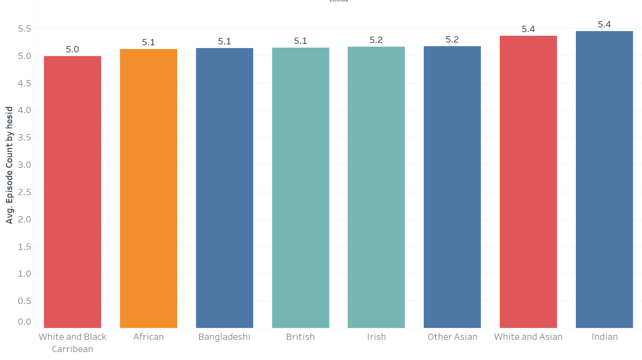

We can see that ethnicity does not seem to be a significant indicator of the average number of episodes.

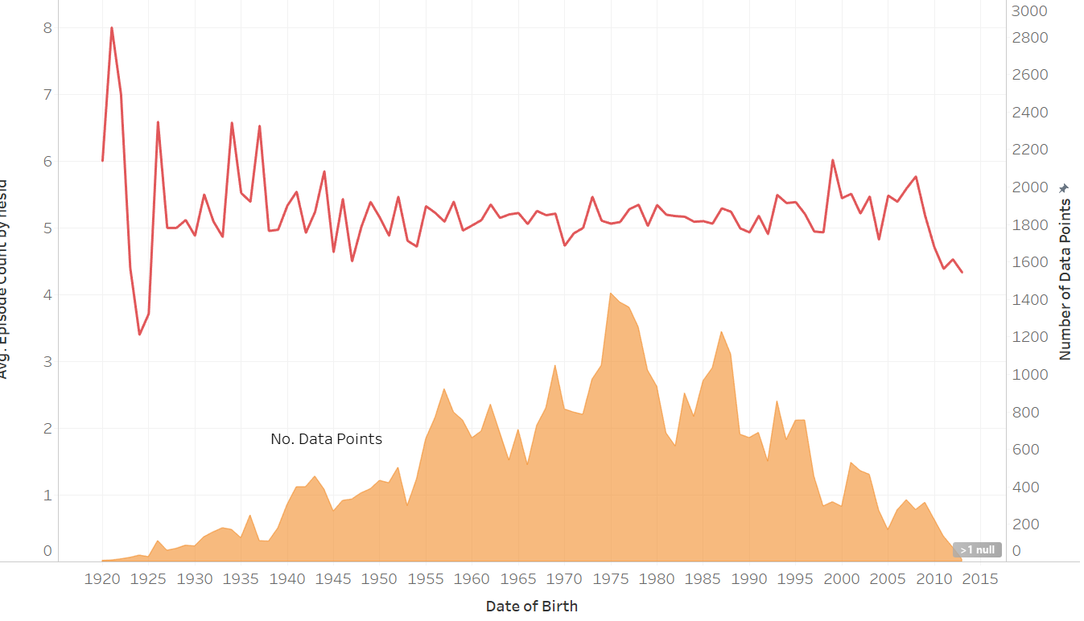

We can also see that Date of Birth doesn’t seem to be a significant indicator of average number of episodes.

I have also done an analysis by gender and have found that women average 5.1 episodes and men 5.2.

**Other Graphs of Interest**

